<https://www.xsens.com/>

For a study on how to make an ergonomic workplace ,Ford did a similar experiment in.

“The skin-tight suit consists of 15 tiny movement tracking light sensors connected to a wireless detection unit. The system tracks how the person moves at work, highlighting head, neck, shoulder and limb movements. Movement is recorded by four specialised motion-tracking cameras – similar to those usually paired with computer game consoles – placed near the worker and captured as a 3D skeletal character animation of the user.”

Even in the film industry, the same technology is used for body tracking.

One example is: OptiTrack: “<https://optitrack.com/motion-capture-animation/>”

This system uses existing cameras for tracking.

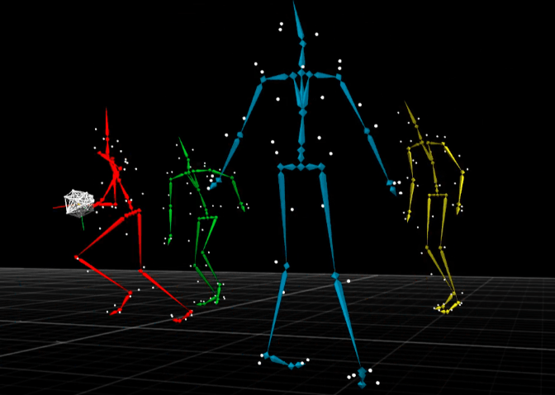

In a way, the “Internet of Things”